CV ( Curriculum Vitae )

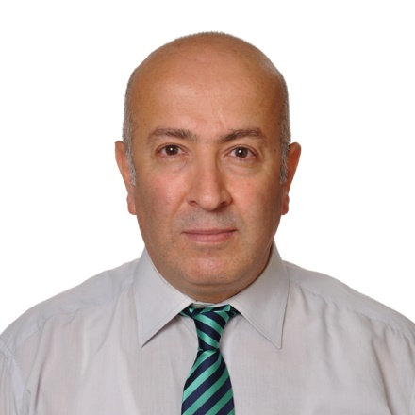

NAME & SURNAME : EROL AVCI

Contact Information
- E-Mails : erolavci1971@gmail.com // erol.avci@yahoo.com
erolavci770@gmail.com // erolavci@webster.edu
- Address : 670 Jamestown Blvd Apt 2318 Altamonte Springs 32714 FL , USA

- Cell Phone : +1 407 675 9226

- Skype : erol.avci42

Personal Information
- Employment Status & Total Experience : 14 Years on IT Field ( Sector )
- Educational Status : University (under Graduate) – COMPUTER ENGINEER
- Educational Status : Master`s Degree ( MS ) in Cybersecurity From Webster University
- Marital Status : Married
- Nationality : Turkey
- Military Status : Completed (10.05.1995)
- Date of Birth : 01.07.1971
- Driver's license : Privately Owned Automobile
- T.C Kimlik No / ID Number : 59191349696
- Passport No : U 10513519

Job Experience
1. Software Development Engineer & Network Admin at KÖKSAL MÜŞAVIRLIK
Job Start Date 01/08/2005 – Job Terminate / End 23/06/2016 ( Total working period / Time 11 years ) in Eskişehir Turkey

Software Development Engineer & Network Administrator at Koksal Musavirlik

- Location: Eskisehir, Turkey
- Company Industry: Accounting / Finance
Job Role: Technology / IT
- Supply & maintain network Infrastructure for the 30 staff workers in our accounting company with Fortigate 1000A network device ,
with this device we can get up to 2Gbps Max Firewall throughput & Max IPSEC VPN Throughput up to 600 Gbps..
- Developing accounting & finance program package, supply & maintain network infrastructure for the company .
Company Details & Address
Company Name : Koksal Musavirlik
Phone & fax number : + 90222-2312334
Address : ISTIKLAL MAH, YEŞILTEPE SOK AYDOĞANLAR APT NO 7/5 ESKIŞEHIR / TURKEY

2. Logistics Responsible & Office Purchaser at GAMA Industry Full-Time
Job Start Date 13/10/2008 – Job Terminate / End 26/04/2010 (Total working period / Time 1,5 year )

- Location : Ras Laffan GTL ( Gas To Liquid) based Project / QATAR
- Company Industry: Gama / Construction
Job Role: Logistics & Purchasing
- Supply Logistics , Purchasing Construction Material & Support it to Construction Area
- Logistics Chief / Responsable : Mehmet Bilici ( Now Working at Zorlu Holding)
- His Phone : +90 543 – 3036163
- Company Details & Address
GAMA Holding
GAMA Binası, Nergis Sokak No:9, 06520 Söğütözü Ankara
+90 (312) 248 42 00
+90 (850) 223 42 62
+90 (312) 248 42 01
Company Name : GAMA HOLDING
Education Information
1. Webster University : Master`s Degree in Cybersecurity
  - Hacettepe University ( Bachelor's Degree) - (Formal Education) Engineering Faculty, Computer Engineering 2.28 / 4 from 08.1993- 08.2014 – Computer Engineer
3.High School 07.1988 Seruk lisesi Science 92 / 100

Foreign language

 |  | Reading | Writing | Speech
Turkish |  | Advanced | Advanced | Advanced
English |  | Advanced | Good | Good
Arabic |  | Advanced | Advanced | Advanced

Native Language
Turkish
Arabic

Competencies
- Computer Skills
Programming on C, C#, DELPHI , JAVA , HTML , PHP , AJAX , JSON , CSS, ASP.NET . NET , SQL & ORACLE Database Configuring & Administration , ASP.NET , Installing/ Configuring Virtual Machines , Installing / Configuring Virtual Machine , Installing / Configuring Wireshark & Nmap -Zenmap (GUI ) , Installing / Configuring Unix / Linux Operating system.

- Certificate Information
MCITP The Microsoft Certified IT Professional (Microsoft Sertifikasyon programları) MİCROSOFT -
MCTS Microsoft Certified Technology Specialist (Microsoft Sertifikasyon programları) MİCROSOFT -
MCAD.NET - Microsoft Certified Application Developer.NET (Microsoft Sertifikasyon programları) MİCROSOFT -
MCP - Microsoft Certified Proffessional (Microsoft Sertifikasyon programları) MİCROSOFT -
MCSE Microsoft Certified Systems Engineers (Microsoft Sertifikasyon programları) MİCROSOFT -
MCSA Microsoft Certified Systems Administrators (Microsoft Sertifikasyon programları) MİCROSOFT -

Additional Information
- Hobbies
Playing chess & pool bilards , reading computer books , swimming …

- Smoking: I don't smoke

